Project Summary
This project is about building a photographer booking application that connects people who need photography services with professional photographers. The system makes it easier for users to search, book, and review photographers, while photographers can manage their profiles, bookings, and track their performance. The project also adds a recommendation system that suggests suitable photographers based on ratings, reviews, and past bookings.

Introduction
Many people face problems finding photographers that match their budget, style, and availability. Photographers also find it difficult to manage their bookings and reach more clients. This project solves these problems by creating a single platform where buyers and photographers can connect easily. It also adds recommendations and performance tracking so both sides can benefit.

Problem Statement
- Buyers do not have a reliable system to find the right photographer.
- Photographers cannot easily manage bookings and show their portfolio.
- Existing platforms lack a simple ranking and monitoring system to match buyers with the best photographers.

Objectives
- Build a simple and user-friendly platform for buyers and photographers.
- Allow photographers to manage their profile, portfolio, and bookings.
- Help buyers search and filter photographers based on different preferences.
- Add a ranking and recommendation system to suggest the best options.
- Provide service monitoring and analytics for performance improvement.
- Ensure smooth platform management through an admin module.

Tools and Technologies
- Frontend: React Native (for mobile app)
- Backend: Python (Django/Flask)
- Database: MySQL
- AI Models: Python (Scikit-learn, Pandas)
- Visualization: Recharts for dashboards

Literature Review
- Freelancing platforms (Fiverr, Upwork): show the need for marketplaces but lack industry focus.
- Photography platforms (Snappr, Shoott): allow bookings but have limited recommendation features.

Vision Statement
To create a simple, reliable, and smart platform that connects photographers and clients with convenience and trust.

Scope Statement
Includes: Registration, profile management, booking, ranking, analytics, admin monitoring.
Excludes: Full online payment integration (will use offline payment for now).

Limitations
- Offline payments only.
- New photographers may not get high ranking at first (system will use default ranking).

Methodology
- Requirement gathering (interviews, questionnaires)
- System design (diagrams, mockups)
- Development of modules step by step
- Dataset collection and preprocessing
- Training ranking and recommendation models
- Integration of booking and monitoring features
- Testing and evaluation

Problem Analysis and Requirement Study
Functional Requirements: Authentication, booking, ranking, analytics, admin monitoring.
Non-Functional Requirements: Scalability, usability, security, real-time responsiveness.

FYP Modules
- Authentication & User Management
- Photographer Module
- Buyer Module
- Booking & Payment Module
- AI Ranking & Recommendation Module
- Service Monitoring & Analytics Dashboard
- Admin Module
- Location-Based Matching Module
12.1 Authentication and User Management
Purpose: To securely handle access, registration, and identity of all users — buyers, photographers, and admins.
Features:
- User Registration and Login
- Password Reset and Change
- Role-Based Access
- Profile Management
- Secure Session Handling
12.2 Photographer Module
Purpose: Allows photographers to manage portfolios, bookings, and ratings.
Features:
- Profile setup and portfolio upload
- Pricing and availability
- Ratings and reviews
- Availability calendar
12.3 Buyer Module
Purpose: Helps users search, explore, and book photographers.
Features:
- Search and filter
- Booking management
- Wishlist
- Reviews and feedback
- In-app messaging
12.4 AI Ranking and Recommendation Module
Purpose: Suggests the most relevant photographers automatically.
Features:
- AI ranking algorithm based on engagement and reviews
- Collaborative and content-based recommendation
- Trending photographers
12.5 Booking and Payment Module
Purpose: Handles booking requests and offline payment confirmations.
Features:
- Offline payment options
- Booking history
- Admin verification
12.6 Service Monitoring and Analytics Dashboard
Purpose: Tracks service performance, bookings, and growth.
Features:
- Performance metrics
- Trend visualization
- Predictive analytics
- Report generation
12.7 Admin Module
Purpose: Allows administrators to manage platform data and users.
Features:
- User management
- Content moderation
- Booking oversight
- Revenue dashboard
12.8 Location-Based Matching Module
Purpose: Matches buyers with nearby photographers.
Features:
- Map integration
- GPS-based matching
- Distance filter

Future Enhancements
- Integration of Online Payment Gateways
Currently, the application supports offline payments such as cash or bank transfer. In the future, secure online payment gateways like PayPal, Stripe, Easypaisa, or JazzCash APIs can be integrated. This enhancement will allow instant booking confirmations and the generation of automated receipts for users, improving transaction reliability and user convenience.
- Multi-Language and Multi-Currency Support
To make the system globally accessible, the platform can include support for multiple languages and currencies. This feature will enable users from different regions to view prices in their local currency and interact with the interface in their preferred language, enhancing user experience and accessibility.
- Cloud Integration and Scalability
The system can be deployed on modern cloud platforms such as Amazon Web Services (AWS) or Google Cloud Platform (GCP). By using cloud databases such as Firebase or AWS RDS, the application will be capable of efficiently handling thousands of concurrent users. Additionally, auto-scaling can be implemented to manage heavy traffic during high-demand event seasons, ensuring optimal system performance and reliability.

Datasets
- Authentication&UserManagement: https://www.kaggle.com/datasets/dasgroup/rba-dataset/discussion
- PhotographerModule: https://www.kaggle.com/datasets/thedevastator/online-course-user-engagement-data
- BuyerModule:
https://www.kaggle.com/datasets/asaniczka/freelance-contracts-dataset-1-3-million-entries
- Ranking&Recommendation: https://www.kaggle.com/datasets/omkarsabnis/yelp-reviews-dataset?utm_source=chatgpt.com
- Booking&Payment:https://www.kaggle.com/datasets/teamincribo/financial-transactions
- AnalyticsDashboard: https://www.kaggle.com/datasets/sasakitetsuya/user-interactions-data-on-an-online-platform
- AdminModule: https://www.kaggle.com/datasets/bhanuthakurr/cleaned-contoso-datase
- LocationMatching: https://www.kaggle.com/datasets/chetanism/foursquare-nyc-and-tokyo-checkin-dataset

Screenshots of these mockups will be inserted below:

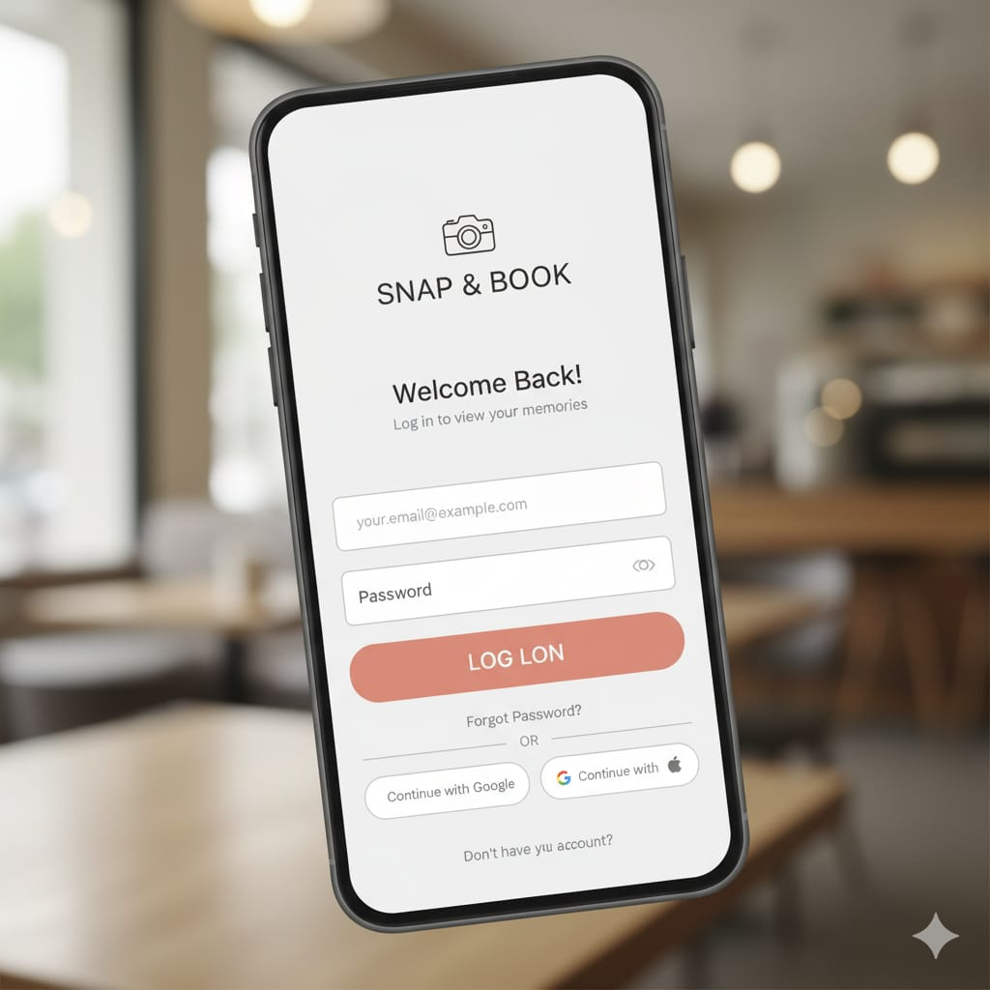
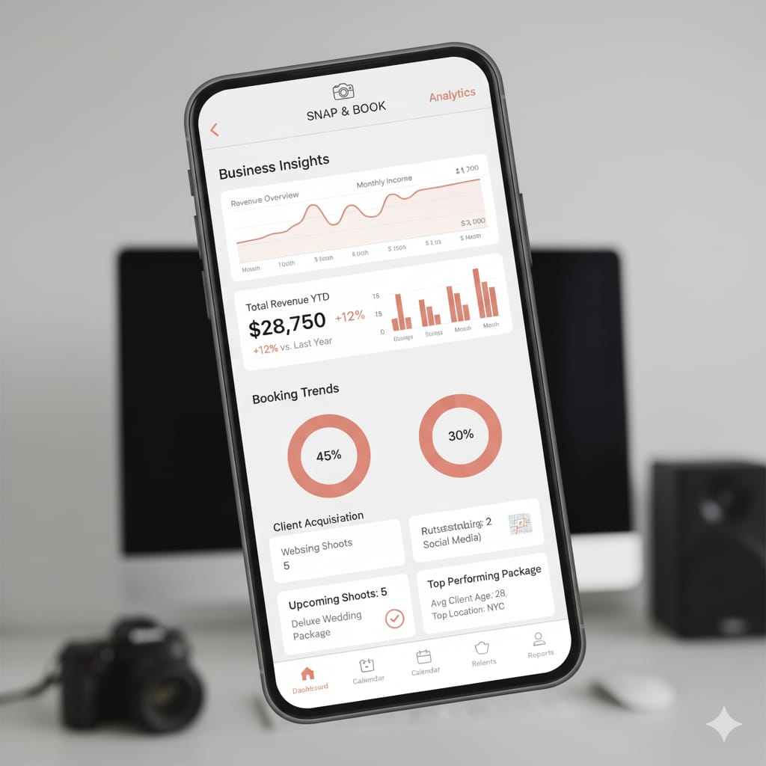



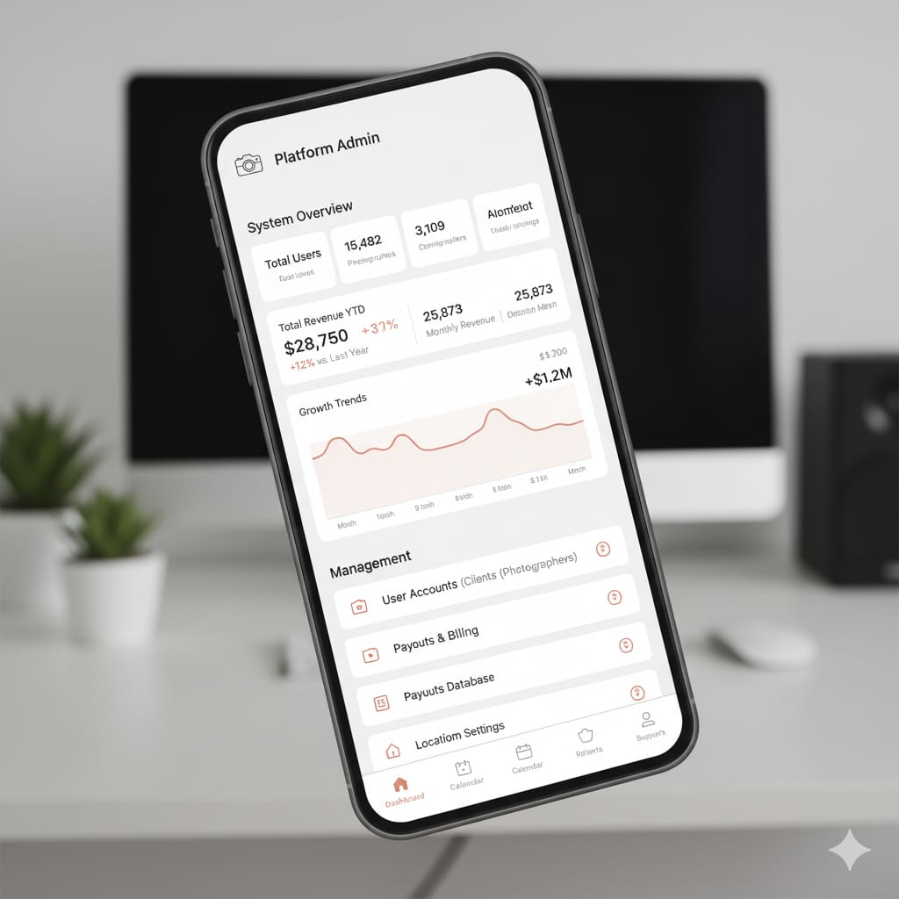
Activity diagram:
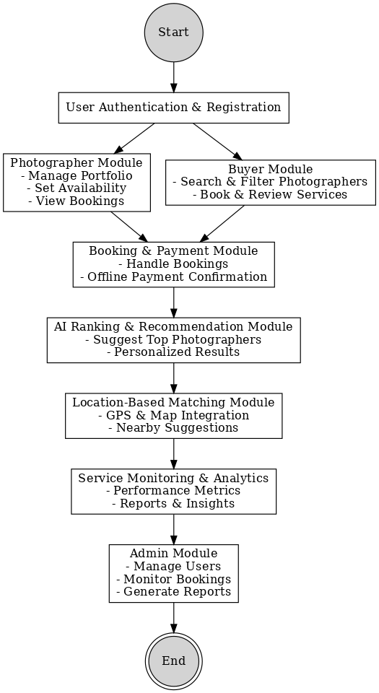
aaaaxsxsjkxbjkbbbbbbbbbbbbbbbbbbbbbbbbbbbbbbbbbbbbbbbbbb

